2009年1月—2016年6月全国居民消费价格指数（CPI）情况
月 份 | 全国同比 | 全国环比 | 月 份 | 全国同比 | 全国环比
2009.1 | 1.0% | 0.9% | 2012.10 | 1.7% | 0.1%
2009.2 | -1.6% | 0.0% | 2012.11 | 2.0% | 0.1%
2009.3 | -1.2% | -0.3% | 2012.12 | 2.5% | 0.8%
2009.4 | -1.5% | -0.2% | 2013.1 | 2% | 1.0%
2009.5 | -1.4% | -0.3% | 2013.2 | 3.2% | 1.1%
2009.6 | -1.7% | -0.5% | 2013.3 | 2.1% | -0.9%
2009.7 | -1.8% | 0.0% | 2013.4 | 2.4% | 0.2%
2009.8 | -1.2% | 0.5% | 2013.5 | 2.1% | -0.6%
2009.9 | -0.8% | 0.4% | 2013.6 | 2.7% | 0.0%
2009.10 | -0.5% | -0.1% | 2013.7 | 2.7% | 0.1%
2009.11 | 0.6% | 0.3% | 2013.8 | 2.6% | 0.5%
2009.12 | 1.9% | 1.0% | 2013.9 | 3.1% | 0.8%
2010.1 | 1.5% | 0.6% | 2013.10 | 3.2% | 0.1%
2010.2 | 2.7% | 1.2% | 2013.11 | 3% | -0.1%
2010.3 | 2.4% | -0.7% | 2013.12 | 2.5% | 0.3%
2010.4 | 2.8% | 0.2% | 2014.1 | 2.3% | 1.0%
2010.5 | 3.1% | -0.1% | 2014.2 | 2.0% | 0.5%
2010.6 | 2.9% | -0.6% | 2014.3 | 2.4% | -0.5%
2010.7 | 3.3% | 0.4% | 2014.4 | 1.8% | -0.3%
2010.8 | 3.5% | 0.6% | 2014.5 | 2.5% | 0.1%
2010.9 | 3.6% | 0.6% | 2014.6 | 2.3% | -0.1%
2010.10 | 4.4% | 0.7% | 2014.7 | 2.3% | 0.1%
2010.11 | 5.1% | 1.1% | 2014.8 | 2.0% | 0.2%
2010.12 | 4.6% | 0.5% | 2014.9 | 1.6% | 0.5%
2011.1 | 4.9% | 1.0% | 2014.10 | 1.6% | 0.0%
2011.2 | 4.9% | 1.2% | 2014.11 | 1.4% | -0.2%
2011.3 | 5.4% | -0.2% | 2014.12 | 1.5% | 0.3%
2011.4 | 5.3% | 0.1% | 2015.1 | 0.8% | 0.3%
2011.5 | 5.5% | 0.1% | 2015.2 | 1.4% | 1.2%
2011.6 | 6.4% | 0.3% | 2015.3 | 1.4% | -0.5%
2011.7 | 6.5% | 0.5% | 2015.4 | 1.5% | -0.2%
2011.8 | 6.2% | 0.3% | 2015.5 | 1.2% | -0.2%
2011.9 | 6.1% | 0.5% | 2015.6 | 1.4% | 0.0%
2011.10 | 5.5% | 0.1% | 2015.7 | 1.6% | 0.3%
2011.11 | 4.2% | 0.2% | 2015.8 | 2.0% | 0.5%
2011.12 | 4.1% | 0.3% | 2015.9 | 1.6% | 0.1%
2012.1 | 4.5% | 1.5% | 2015.10 | 1.3% | -0.3%
2012.2 | 3.2% | -0.1% | 2015.11 | 1.5% | 0.0%
2012.3 | 3.6% | 0.2% | 2015.12 | 1.6% | 0.5%
2012.4 | 3.4% | -0.1% | 2016.1 | 1.8% | 0.5%
2012.5 | 3.0% | -0.3% | 2016.2 | 2.3% | 1.6%
2012.6 | 2.2% | -0.6% | 2016.3 | 2.3% | -0.4%
2012.7 | 1.8% | 0.1% | 2016.4 | 2.3% | -0.2%
2012.8 | 2.0% | 0.6% | 2016.5 | 2.0% | -0.5%
2012.9 | 1.9% | 0.3% | 2016.6 | 1.9% | -0.1%

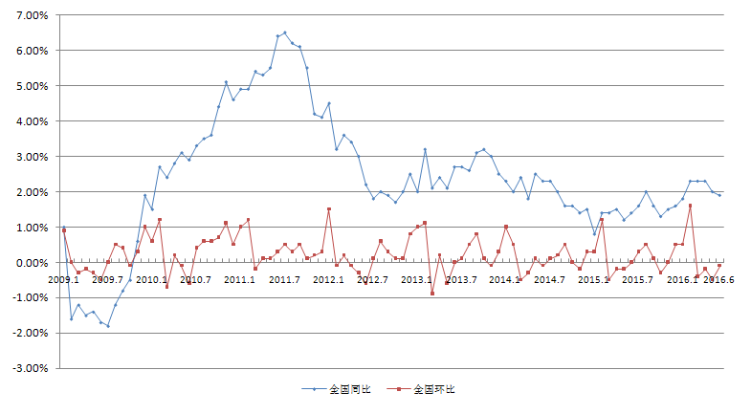

2009年1月—2016年6月全国居民消费价格指数（CPI）情况

